



Chemistry Project on

Analysis of Artificial Sweetners

# Academic Session: 2025-26

**Submitted by: Nishit Kumar**

**Roll No.: 20**

**Grade: XII Science Stream: CBSE**

**CBSE Exam no:**

**CITY PRIDE SCHOOL, NIGDI**

**Department of Chemistry**

**CERTIFICATE**

This is to certify that Nishit Kumar a student of class XII, Exam Seat

No. has successfully completed the investigatory project on Analysis of Artificial Sweeteners in Diet Cold drinks during the academic session 2025-26 in the partial fulfilment of the Chemistry practical examination conducted by the CBSE.

Internal Examiner External Examiner

Vice Principal Principal

## ACKNOWLEDGEMENT

I would like to express my greatest appreciation to everyone who helped and supported me throughout the project.

I am indebted to the Principal, Vice Principal and the entire faculty of City Pride School for their support in successful completion of this investigatory project

I am thankful to my Chemistry Teacher, Ms. Priyanka S. for her advice and encouragement that played a huge role to finalize this project report. I am also grateful to our Lab Assistant Ms. Swapna P. for her valuable guidance and support.

I would also like to thank all of my classmates who helped me in completing the project by exchanging interesting ideas and sharing their experiences.

I wish to thank my parents as well for their support and encouragement without which I could not have completed this project in the limited timeframe.

At the end, I want to thank my friends who displayed appreciation to my work and motivated me to continue my work.

-Nishit Kumar

# INDEX

|  |  |  |
| --- | --- | --- |
| **Sr. No.** | **Contents** | **Page No.** |
| 1 | Abstract | 5 |
| 2 | Objective | 7 |
| 3 | Requirements | 7 |
| 4 | Methodology | 9 |
| 5 | Data | 15 |
| 6 | Results | 24 |
| 7 | Conclusion | 25 |
| 8 | Glossary | 27 |
| 9 | Bibliography | 28 |

**Abstract:**

Are you curious about what makes your favorite diet drinks sweet yet calorie- free? Look no further! This project dives deep into the fascinating world of artificial sweeteners, the hidden stars behind the sweetness in **Diet Coke,** **Red Bull Sugarfree, Moster Ultra Black and Sting energy**. These sweeteners, **Aspartame** and **Acesulfame Potassium (Ace-K)**, are designed to provide sweetness without the added sugar, offering a healthier alternative for those who can't resist their fizzy favorites.

Artificial sweeteners like Aspartame and Ace-K are unique compounds with distinctive properties. Aspartame is a low-calorie sweetener with a slightly neutral nature, while Ace-K offers stability under heat and acidic conditions. Both are key components in modern diet beverages, replacing sugar while keeping the taste intact.

Through this project, we unravel the properties and behaviors of these sweeteners using chemical methods such as **paper chromatography**, **pH testing**, **solubility testing**, **conductivity measurement**, and **acid-base titration**. These analyses not only highlight the role of Aspartame and Ace-K but also shed light on their chemical characteristics, safety, and functionality in beverages.

So, whether you’re a science enthusiast or a fan of diet drinks, this study uncovers the chemistry behind the sweetness and provides insights into these fascinating sugar substitutes!

Structure of Acesulfame Potassium

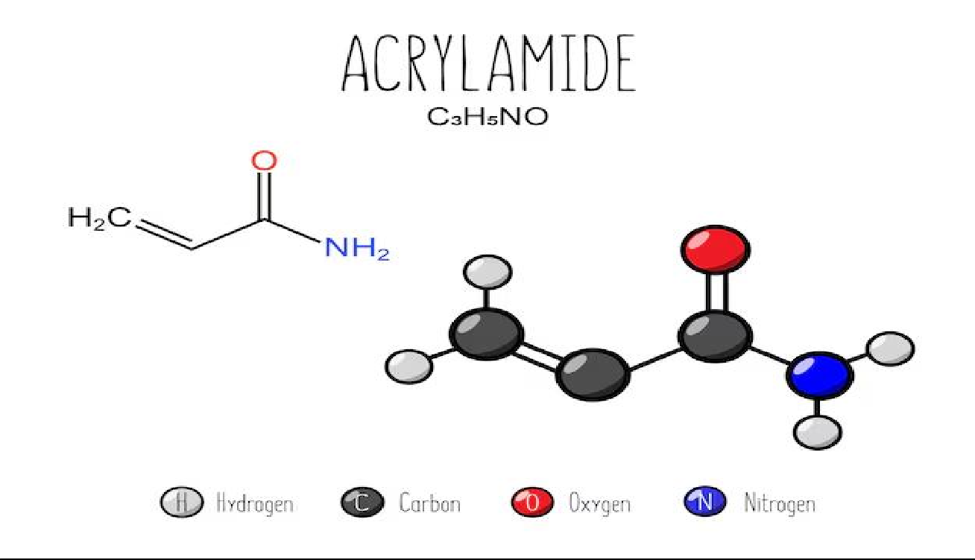

Structure of Aspartame

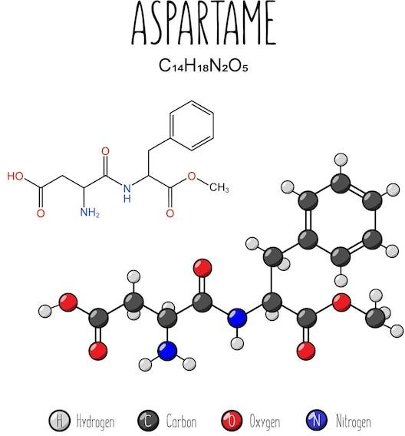

### **Objective:**

### To identify and analyze the presence and properties of **Aspartame** and **Acesulfame Potassium (Ace-K)** in **Diet Coke,** **Red Bull Sugarfree, Monster Ultra black and Sting energy** using:

* **Paper Chromatography**
* **pH Testing**
* **Solubility Testing**
* **Conductivity Measurement**
* **Acid-Base Titration**
* **Test for sugar/Caramelization test**

### **Requirements:**

**Samples**

* Diet Coke (100 mL)
* Red Bull Sugarfree (100 mL)
* Moster Ultra Black(100mL)
* Sting energy(100ml)

**Chemicals**

* Sodium Hydroxide (NaOH) solution (0.1 M)
* Distilled Water
* Ethanol
* Benzene
* Phenolphthalein Indicator
* pH Paper or pH Meter
* Calcium Hydroxide powder
* Iodine for iodine vapors

**Apparatus**

* Titration Flask
* Burette
* Pipette
* Measuring Flask
* Filter Paper
* Beakers
* Multimeter

**Methodology:**

##### PREPARATION:

**Sample Extraction**

1. Pour 100 mL of each drink into separate beakers.
2. Gently heat to evaporate half the liquid.
3. Add 10 mL of distilled water and filter the solution

##### 70% Ethanol Solution

1. Pour 17.5ml of 99%~100% ethanol in a measuring flask
2. Gently fill the remaining measuring flask till 25ml.

##### M NaOH solution from 1M NaOH solution

* + 1. Take 10 mL of 1 M NaOH using a pipette.
    2. Add distilled water to make the total volume up to 50 mL.
    3. Mix thoroughly to ensure uniform concentration.

##### Preparation of Ca(OH)2

1. Weigh 0.03 g of Ca(OH)₂ powder.
2. Add the powder to a beaker and slowly add 20 mL of distilled water.
3. Stir the mixture until the powder dissolves (some undissolved powder may remain).

**TESTS**

**Test for Conductivity**

* 1. The extracted sample is diluted with distilled water as needed.
  2. Two copper wires or metal probes are inserted into the solution.
  3. The probes are connected to a multimeter or conductivity meter to measure the resistance of the solution.
  4. The conductivity is measured:
     + Aspartame will show high resistance, indicating low conductivity (non- ionic).
     + Ace-K will show low resistance, indicating high conductivity (ionic).

**Paper Chromatography**

**Test for Aspartame (Paper Chromatography):**

1. 2 mL of the extracted sample from **Diet Coke** or **Red Bull Sugarfree** is taken in a test tube.
2. Using a capillary tube, a small amount (1-2 μL) of the sample is applied to a baseline drawn on a **6 cm filter paper strip**.
3. The filter paper is placed in a chromatography chamber containing a **70% ethanol and 30% water** solvent mixture.
4. The solvent moves up the paper, separating the components of the sample.
5. After the solvent has moved about 4-5 cm, the paper is removed and allowed to dry.
6. The spots are visualized using **UV light** or **iodine vapor** to identify the presence of **Aspartame**. The distance traveled by the Aspartame spot is compared with known standards.

**Test for Acesulfame Potassium (Ace-K) (Paper Chromatography):**

1. The same procedure is followed as for Aspartame in the **Red Bull Sugarfree and Monster Ultra Black** sample.
2. The chromatogram is observed for a distinct spot that corresponds to **Ace-K**

based on the distance traveled.

**Test for pH (pH Testing):**

1. 2 mL of the extracted sample from **Diet Coke/Red Bull Sugarfree/Monster Ultra Black** is placed in separate test tubes.
2. The pH of each sample is measured using **pH paper** or a **pH meter**.
3. The pH values are recorded for each sample:
   * Aspartame (Diet Coke) should show a **neutral pH (~7)**.
   * Ace-K (Red Bull Sugarfree)should show a **slightly acidic pH (~4-5)**.
   * Sting Energy should a slightly acidic pH(~4.5)
   * Monster Ultra Black should show an acidic ph of around 3.8

**Test for Solubility (Solubility Testing):**

1. 2 test tubes are prepared for each sample.
2. 5 mL of each extracted sample is added to the test tubes.
3. To one test tube, **5 mL of distilled water** is added, and to the other, **5 mL of ethanol** is added.
4. The mixture is stirred, and the solubility of the sweeteners is observed:
   * **Aspartame** will dissolve in **water** but will be insoluble in **ethanol**.
   * **Ace-K** will dissolve in water and ethanol.
   * **Ace-K is not soluble in Benzene**

**Test for Aspartame and Ace-K (Titration - Acid-Base):**

1. **10 mL** of each drink (Diet Coke, Red Bull Sugarfree, Sting, Monster Ultra Black) is taken in separate titration flasks.
2. **2-3 drops of phenolphthalein indicator** are added to each sample.
3. **0.1 M NaOH solution** is added drop by drop from a burette while stirring until a **persistent pink color** is observed.
4. The **volume of NaOH used** is recorded.
5. **Moles of NaOH** are calculated using the formula:

**Moles of NaOH = Concentration × Volume (in liters)**

1. Since Aspartame, Ace-K, and Sucralose react with NaOH in a **1:1 molar ratio**:

**Moles of NaOH = Moles of Sweetener**

1. The **strength of the sweetener** in the drink is calculated using:

**Strength (g/L) = Molarity (mol/L) × Molar Mass (g/mol)**

### Reactions:

**1. Acid-Base Titration Reactions**

General Reaction Format:

Acidic component (from sweetener or additive) reacts with sodium hydroxide:

Acid + NaOH → Salt + Water

a) Aspartame

Aspartame contains a carboxylic acid group, which reacts with NaOH as follows:

Aspartame–COOH + NaOH → Aspartame–COO⁻Na⁺ + H₂O

b) Acesulfame Potassium (Ace-K)

Acts as a weak acid due to its sulfonamide group:

Ace-K + NaOH → Ace-K Sodium Salt + H₂O

c) Sucralose

Sucralose is very weakly reactive with NaOH. In titration, its contribution is minimal:

Sucralose + NaOH → (Trace reaction) + H₂O

*Note: Sucralose’s effect in titration is minor; most NaOH reacts with stronger acids like Ace-K*

*or additives.*

d) Citric or Phosphoric Acid (Additives in drinks)

Citric Acid:

C₆H₈O₇ + 3NaOH → Na₃C₆H₅O₇ + 3H₂O

Phosphoric Acid:

H₃PO₄ + 3NaOH → Na₃PO₄ + 3H₂O

**2. Conductivity Test**

This test detects ion dissociation (not a chemical reaction).

Ace-K (ionic sweetener):

Ace-K → Ace⁻ + K⁺

This free ion movement allows electrical conductivity.

Aspartame and Sucralose do not dissociate into ions and show very low conductivity.

**3. pH Test**

This test measures H⁺ ion concentration and does not involve a chemical reaction.

* Aspartame: Neutral (pH ~7)
* Ace-K: Slightly acidic (pH ~4–5)
* Citric/Phosphoric acid: Strongly acidic (pH ~3–4)

**4. Paper Chromatography**

This is a physical separation process, not a chemical reaction. Sweeteners separate based on solubility and affinity to the solvent and paper.**5. Solubility Test**

This is a physical process where sweeteners dissolve in solvents. No chemical reaction occurs.

Sweetener + Solvent → Dissolved sweetener solution**6. Caramelization (Dry Heating Test – if sugar is present)**

If sugar (like sucrose) is present, it undergoes thermal decomposition upon heating:

C₁₂H₂₂O₁₁ (Sucrose) → Caramel + Water + Brown Residue (on heating)

* Results in browning and burnt sugar smell.
* Artificial sweeteners like Aspartame or Ace-K do not caramelize but may decompose or char.

**Calculations:**

**1. Acesulfame Potassium (Ace-K) – Red Bull Sugarfree**

* If 5 mL of 0.1 M NaOH is required:  
  Moles of NaOH = 0.1 M × 0.005 L = 0.0005 moles
* Moles of Ace-K = 0.0005 moles
* For a 10 mL sample (0.01 L):  
  Molarity = 0.0005 / 0.01 = 0.05 mol/L
* Molar Mass of Ace-K = 201.2 g/mol
* Strength = 0.05 mol/L × 201.2 g/mol = **10.06 g/L**

**2. Aspartame – Diet Coke**

* If 6 mL of 0.1 M NaOH is required:  
  Moles of NaOH = 0.1 M × 0.006 L = 0.0006 moles
* Moles of Aspartame = 0.0006 moles
* For a 10 mL sample (0.01 L):  
  Molarity = 0.0006 / 0.01 = 0.06 mol/L
* Molar Mass of Aspartame = 294.3 g/mol
* Strength = 0.06 mol/L × 294.3 g/mol = **17.66 g/L**

**3. Aspartame + Sucralose – Sting**

* If 5.5 mL of 0.1 M NaOH is required:  
  Moles of NaOH = 0.1 M × 0.0055 L = 0.00055 moles
* Moles of sweeteners (combined) = 0.00055 moles
* For a 10 mL sample (0.01 L):  
  Molarity = 0.00055 / 0.01 = 0.055 mol/L
* Average Molar Mass = (294.3 + 397.6) / 2 = 345.95 g/mol
* Strength = 0.055 mol/L × 345.95 g/mol = **19.03 g/L**

**4. Ace-K + Sucralose – Monster Ultra Black**

* If 6.5 mL of 0.1 M NaOH is required:  
  Moles of NaOH = 0.1 M × 0.0065 L = 0.00065 moles
* Moles of sweeteners (combined) = 0.00065 moles
* For a 10 mL sample (0.01 L):  
  Molarity = 0.00065 / 0.01 = 0.065 mol/L
* Average Molar Mass = (201.2 + 397.6) / 2 = 299.4 g/mol
* Strength = 0.065 mol/L × 299.4 g/mol = **19.46 g/L**

### Data:

OBSERVATION TABLE:

|  |  |  |  |
| --- | --- | --- | --- |
| **SR NO.** | **TESTS** | **OBSERVATION** | **INFERENCE** |
| 1. | **Test for Conductivity**  Sample + Multimeter/Conductivity meter | - **Diet Coke (Aspartame):** High resistance- **Red Bull SF (Ace-K):** Low resistance- **Sting (Aspartame + Sucralose):** Moderate resistance- **Monster Ultra Black (Ace-K + Sucralose):** Low resistance | - Aspartame is non-ionic (low conductivity)- Ace-K is ionic (high conductivity)- Sucralose slightly increases conductivity- Blends show medium to high conductivity |
| 2. | **Test for Aspartame (Paper Chromatography)**  Sample + Ethanol/Water solvent mixture | - Spot corresponding to Aspartame seen in **Diet Coke** and **Sting** | Aspartame is present in Diet Coke and Sting |
| 3. | **Test for Ace-K (Paper Chromatography)**  Sample + Ethanol/Water solvent mixture | - Spot corresponding to Ace-K seen in **Red Bull SF** and **Monster Ultra Black** | Ace-K is present in Red Bull Sugarfree and Monster Ultra Black |
| 4. | **Test for pH**  Sample + pH paper or pH meter | - **Diet Coke:** pH ~7- **Red Bull SF:** pH ~4–5- **Sting:** pH ~4.5- **Monster Ultra Black:** pH ~3.8 | - Aspartame is neutral- Ace-K and Sucralose contribute to acidity- Energy drinks are mildly acidic |
| 5. | **Test for Solubility**  Sample + Water/Ethanol | - **Aspartame:** Soluble in water, not in ethanol- **Ace-K & Sucralose:** Soluble in both- **Sting & Monster:** Fully soluble in both | - Aspartame is polar- Ace-K is ionic- Sucralose is moderately polar- Blends dissolve in both solvents |
| 6. | **Test for Titration (Acid-Base)**  Sample + 0.1 M NaOH | - **Diet Coke:** 6 mL- **Red Bull SF:** 5 mL- **Sting:** 5.5 mL- **Monster Ultra Black:** 6.5 mL | - Higher NaOH volume = more acidic compounds- Monster is most acidic- Red Bull is mildly acidic- Sting and Diet Coke are in between |

**SAMPLES USED FOR ANALYSIS:**

Diet Coke Red Bull Sugar Free

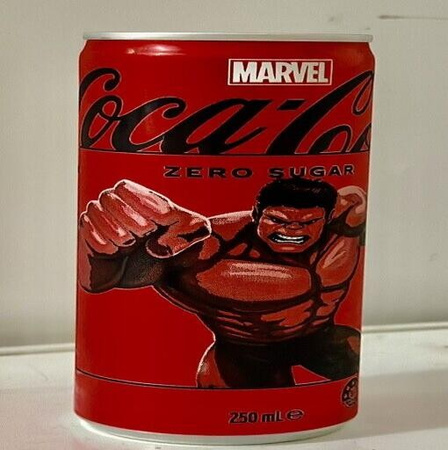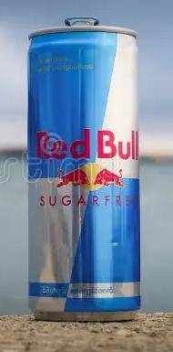

Monster Ultra Black Sting Energy

###### Wholesale Monster-Ultra Energy Drink /Wholesale Monster Energy Energy Drink at ₹ 500/carton | मॉन्स्टर एनर्जी ड्रिंक in Mumbai | ID: 2853319689573 Sting S1 Energy Drink

###### Materials used

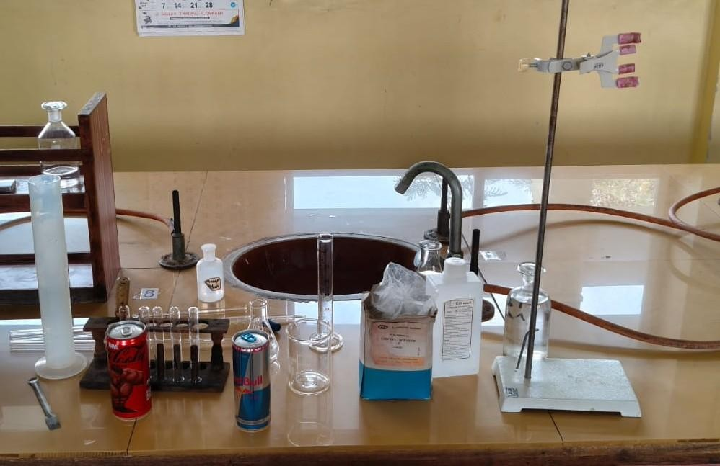

**SAMPLE PREPARATION**

70% Ethanol 0.1M Naoh Solution Ca(OH)2

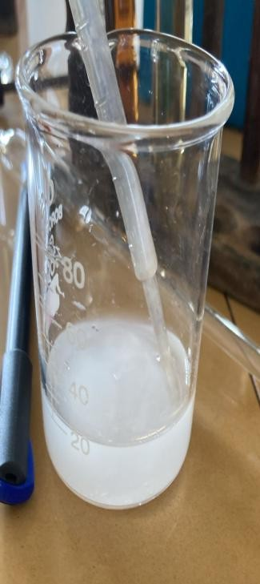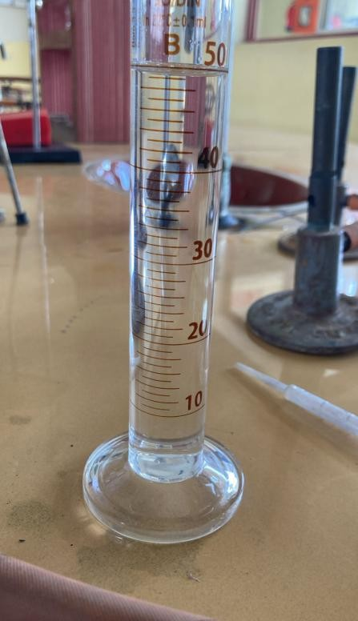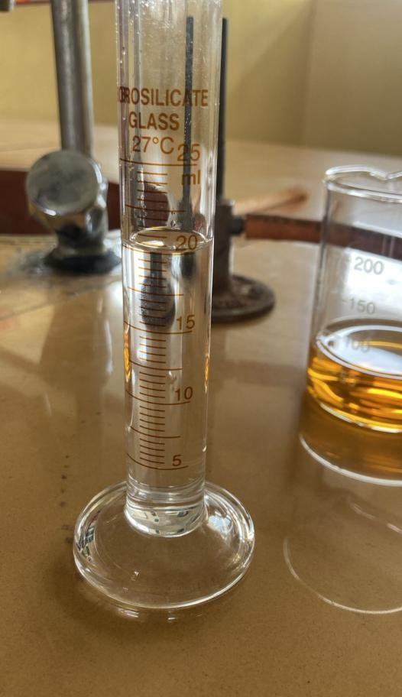

###### Conductivity Test

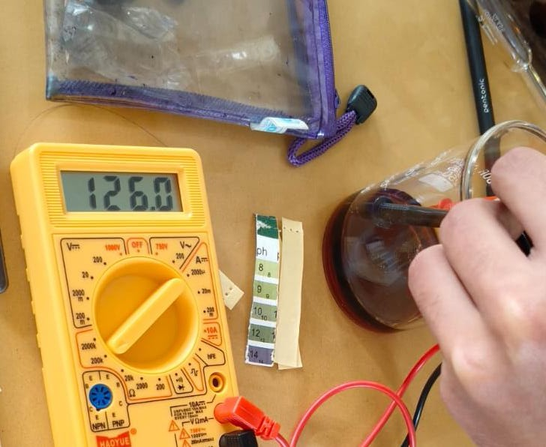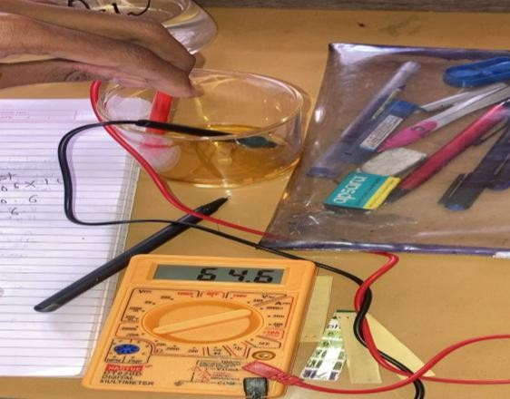Redbull(Ace-K) Diet coke(Asartame)

Monster Ultra Sting 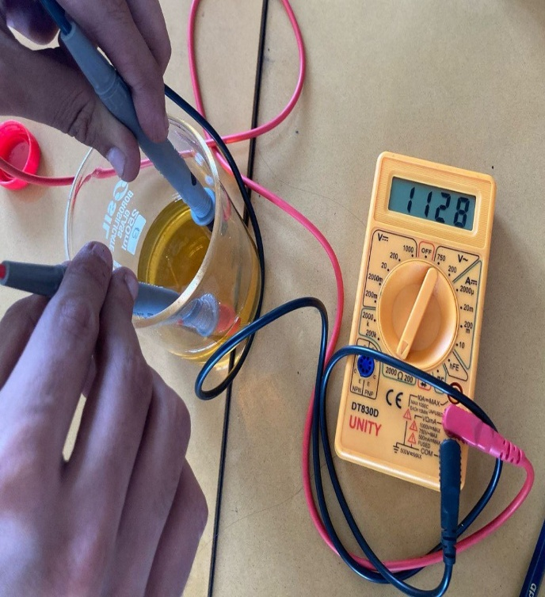 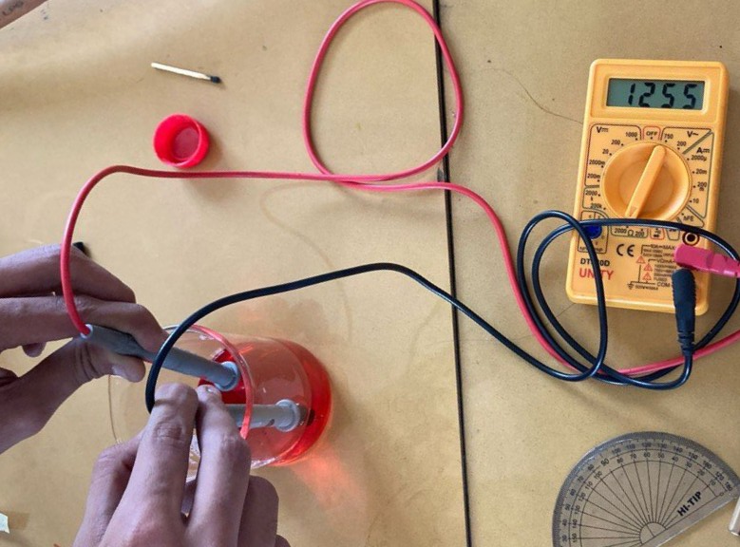

###### Thin Layer Chromatography

Red Bull (Ace-K) Diet Coke(Aspartame)

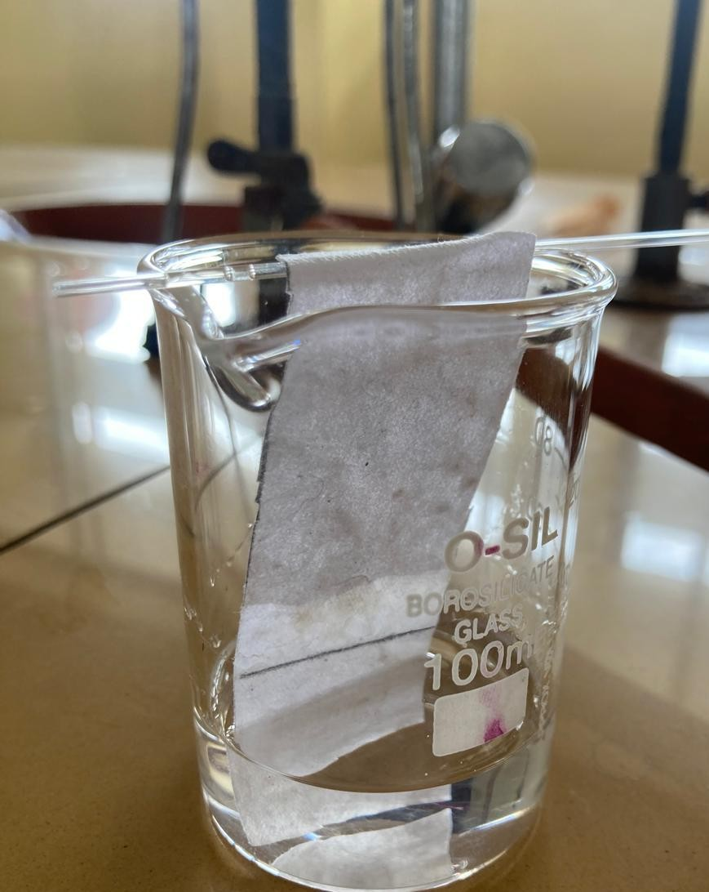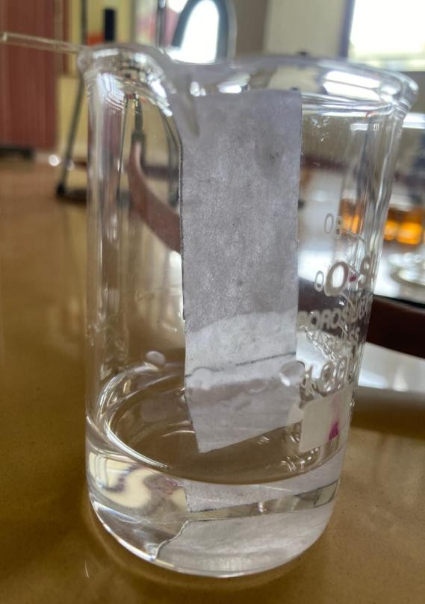\

 Monster Ultra Sting



###### pH Test

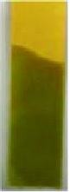Diet Coke Redbull Monster Ultra Sting Energy

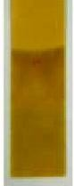

###### Solubility Test

###### Red Bull and Diet Coke

Ethanol Distilled Water

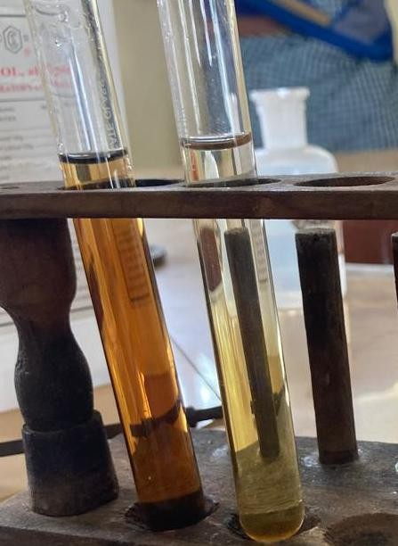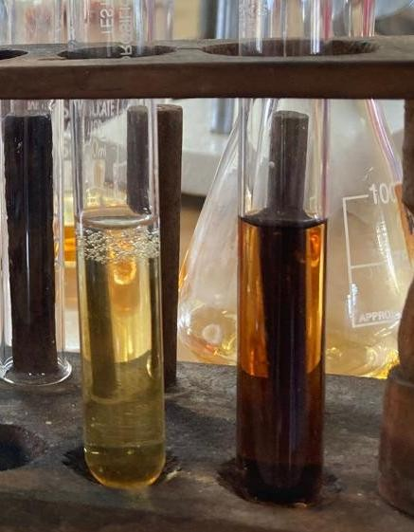

Monster Ultra Black and Sting

**Water and ethanol** Ace-K + Benzene (insoluble)

**5. Sucralose/Caramelization Test**

**Sting Monster Black**

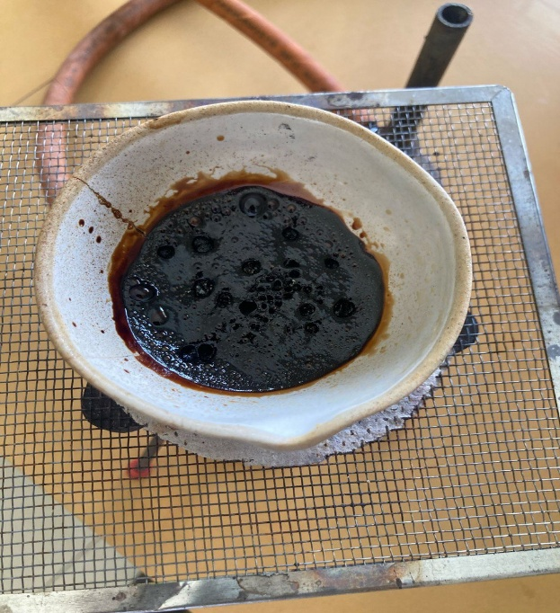

###### 6. Titration Test

Red bull (Ace-k) And Sting

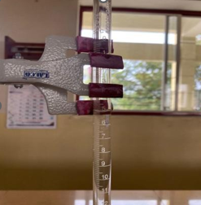 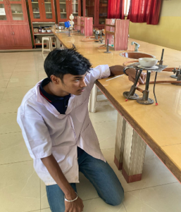 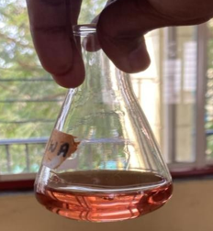

Diet Coke(Aspartame)

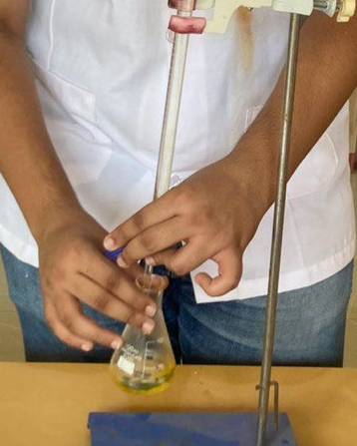

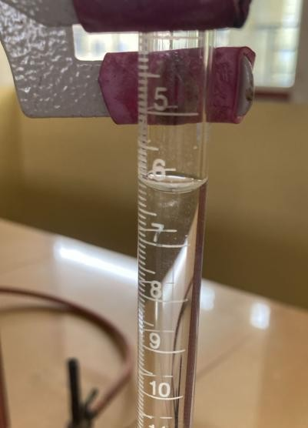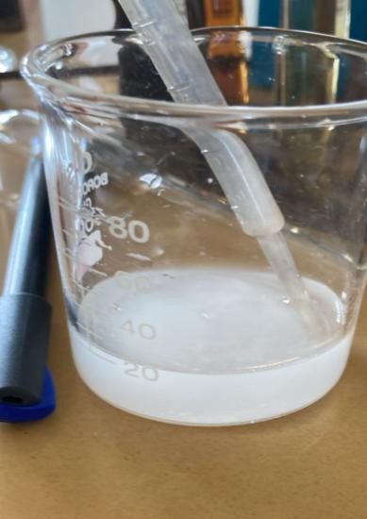

Monsterblack(Ace-k)

#### RESULT

**1. Sample Extraction**

* Clear filtrates were obtained for Diet Coke, Red Bull Sugarfree, Sting, and Monster Ultra Black, indicating the presence of soluble artificial sweeteners.

**2. Paper Chromatography**

* Two distinct spots were observed in all samples.
  + Diet Coke and Sting showed a spot corresponding to Aspartame.
  + Red Bull Sugarfree and Monster Ultra Black showed a spot corresponding to Ace-K.
  + Sucralose presence was inferred in **Sting** and **Monster**, though less distinctly visible.

**3. pH Testing**

* **Diet Coke**: pH ~7 (neutral, indicating mild acidity possibly from phosphoric acid).
* **Red Bull Sugarfree:** pH ~4–5 (slightly acidic, due to citric acid).
* **Sting**: pH ~4.5 (mildly acidic).
* **Monster Ultra Black:** pH ~3.8 (more acidic, likely from added preservatives and acids).

**4. Solubility Testing**

* **Aspartame**: Soluble in water, not soluble in ethanol.
* **Ace-K**: Soluble in both water and ethanol.
* **Sucralose**: Soluble in both water and ethanol.
* **All four drinks** showed complete solubility in polar solvents, but no solubility in non-polar solvents like hexane or benzene

**5. Conductivity Measurement**

* **Diet Coke:** High resistance (Aspartame – non-ionic).
* **Red Bull Sugarfree:** Low resistance (Ace-K – ionic).
* **Sting:** Moderate resistance (Aspartame + Sucralose).
* **Monster Ultra Black:** Low resistance (Ace-K + Sucralose).

**6. Acid-Base Titration**

|  |  |  |
| --- | --- | --- |
| **Drink** | **NaOH Required (0.1 M)** | **Inference** |
| Diet Coke | 6 mL | Slightly acidic due to added acids; Aspartame present |
| Red Bull Sugarfree | 5 mL | Mild acidity; contains Ace-K |
| Sting | 5.5 mL | Slightly more acidic than Diet Coke; contains Aspartame + Sucralose |
| Monster Ultra Black | 6.5 mL | Most acidic; contains Ace-K + Sucralose |

**Conclusion**

From the above experiments, we understand that artificial sweeteners such as Aspartame, Acesulfame Potassium (Ace-K), and Sucralose are widely used in sugar-free and energy drinks like Diet Coke, Red Bull Sugarfree, Sting, and Monster Ultra Black.

Each sweetener has distinct chemical properties and contributes to the overall acidity, solubility, and behavior of the drink:

* Aspartame is non-ionic, shows neutral pH, and is soluble only in water.
* Ace-K is ionic, shows slightly acidic pH, and is soluble in both water and ethanol.
* Sucralose, though non-ionic, shows mild interaction in titration and is soluble in both solvents.

The titration results further confirm the presence and relative acidity levels of these drinks:

* Monster Ultra Black was the most acidic.
* Red Bull Sugarfree was the least.
* Sting and Diet Coke were moderate.

These results showcase the effectiveness of artificial sweeteners in replacing sugar without adding calories, while also highlighting differences in their chemical behaviors and concentrations.

**Recommended Daily Intake (ADI):**

1. **Aspartame**
   * ADI = 40 mg per kg of body weight
   * For an average 70 kg adult:  
     **2800 mg/day**
2. **Acesulfame Potassium (Ace-K)**
   * ADI = 15 mg per kg of body weight
   * For an average 70 kg adult:  
     **1050 mg/day**
3. **Sucralose**
   * ADI = 5 mg per kg of body weight
   * For an average 70 kg adult:  
     **350 mg/day**

**Precautions**

1. **Moderation is Key**
   * Artificial sweeteners are safe within ADI limits but excessive use may cause side effects such as **headaches, digestive issues**, or **allergic reactions**.
2. **Health Conditions**
   * People with **Phenylketonuria (PKU)** must avoid **Aspartame**, as it contains **phenylalanine**.
   * People with **allergies or sensitivities** should consult a doctor before

regular use.

1. **Avoid Over-Reliance**
   * Using artificial sweeteners excessively as sugar replacements may lead to **dietary imbalances** or overdependence on **processed foods**.
2. **Children and Pregnant Women**
   * Should prefer **natural sweeteners** when possible, though occasional use

is generally considered safe.

**Glossary**

1. **Aspartame**  
   A low-calorie artificial sweetener, about 200 times sweeter than sugar. Found in **Diet Coke** and **Sting**. It is **heat-sensitive** and has a **neutral pH**.
2. **Acesulfame Potassium (Ace-K)**  
   A calorie-free, **ionic** sweetener that is **heat-stable** and used in **Red Bull Sugarfree** and **Monster Ultra Black**.
3. **Sucralose**  
   A chlorinated sugar substitute that is **stable under heat**, **non-caloric**, and used in **Sting** and **Monster Ultra Black**.
4. **Diet Coke**  
   A soft drink sweetened with **Aspartame**, providing sweetness without sugar.
5. **Red Bull Sugarfree**  
   A sugar-free energy drink containing **Ace-K** as its main sweetener.
6. **Sting**  
   A sweet energy drink containing **Aspartame** and **Sucralose**, showing moderate acidity.
7. **Monster Ultra Black**  
   A sugar-free energy drink sweetened with **Ace-K** and **Sucralose**, showing highest acidity among samples.
8. **Artificial Sweeteners**  
   Chemical compounds that provide **sweetness without calories**, commonly used in **diet and sugar-free** products.
9. **Paper Chromatography**  
   A lab technique used to **separate and identify components** in a mixture based on their movement on filter paper.

Bibliography-

* 1. [https://www.fda.gov/food/food-additives-petitions/additional-information-](https://www.fda.gov/food/food-additives-petitions/additional-information-about-high-intensity-sweeteners-permitted-use-foods) [about-high-intensity-sweeteners-permitted-use-foods](https://www.fda.gov/food/food-additives-petitions/additional-information-about-high-intensity-sweeteners-permitted-use-foods)
  2. <https://www.efsa.europa.eu/en/efsajournal/pub/5372>
  3. <https://www.ncbi.nlm.nih.gov/pmc/articles/PMC7236406/>
  4. <https://www.sciencedirect.com/topics/food-science/artificial-sweetener>
  5. <https://www.nhs.uk/live-well/eat-well/are-sweeteners-safe/>
  6. [https://www.researchgate.net/publication/325213567_Artificial_Sweeteners_](https://www.researchgate.net/publication/325213567_Artificial_Sweeteners_and_Their_Health_Impact) [and_Their_Health_Impact](https://www.researchgate.net/publication/325213567_Artificial_Sweeteners_and_Their_Health_Impact)
  7. <https://www.who.int/news-room/fact-sheets/detail/artificial-sweeteners>